
HOSPITAL MANAGEMENT SYSTEM
(ASP.NET Project)
Three-Tier Architecture
Group Members:
- Abdul Hadi Abbasi - Roll No: 3341
- Farheen Asif - Roll No: 3387

Submitted To:
Mr. Ehtisham Noor

Hospital Management System (Three-Tier Architecture)

1. Introduction
The Hospital Management System (HMS) is a role-based web application developed in C# using Three-Tier Architecture. The system is designed to efficiently manage hospital operations by providing separate panels for Admin, Doctor, and Patient. Each role has defined permissions to ensure data security, scalability, and ease of management.
The application supports patient registration, appointment booking, doctor prescription management, report handling, and administrative control over doctors, patients, and appointments.

1(a). Problem Statement
Traditional hospital management processes are mostly manual or semi-automated, leading to several issues:
- Difficulty in managing patient records
- Lack of centralized appointment scheduling
- Inefficient communication between doctors and patients
- Data redundancy and inconsistency
- Time-consuming administrative tasks
- Poor tracking of prescriptions and medical reports
These problems result in delayed services, errors in data handling, and reduced overall efficiency of hospital operations.

1(b). Objectives
The main objectives of the Hospital Management System are:
- To automate hospital management processes
- To provide role-based secure access (Admin, Doctor, Patient)
- To allow patients to book appointments with specific doctors
- To enable doctors to manage prescriptions and patient reports
- To help administrators manage doctors, patients, and appointments
- To ensure proper record keeping and easy data retrieval
- To reduce paperwork and manual effort

1(c). Project Scope
The scope of the project includes the following modules:

Patient Module
- Patient registration and login
- Selection of a specific doctor during registration or appointment booking
- Book appointment with date and time
- View booked appointments
- View uploaded prescriptions and medical reports
- Dashboard showing appointment details
- Logout functionality

Doctor Module
- Doctor login
- View “My Appointments” with assigned patients
- View “My Patients” (only assigned patients)
- Upload prescriptions for specific patients
- Upload and manage patient medical reports
- View patient details
- Logout functionality

Admin Module
- Admin login
- Manage doctors (Add, Update, Delete, View)
- Manage patients (Add, Update, Delete, View)
- Manage appointments (Schedule, Update, Cancel)
- View all appointments with patient, doctor, date, and time details
- Dashboard overview of system data

Technical Scope
- Developed using C#
- Three-Tier Architecture (Presentation, Business Logic, Data Access)
- Role-Based Authentication and Authorization
- SQL Server database

1(d). Implementation Timeline (MS Project Based)

Microsoft Project
Used Microsoft Project to create the project schedule of the Hospital Management System. A Gantt Chart was prepared to show different phases, tasks, and their durations. This helped in planning, monitoring, and completing the project on time.
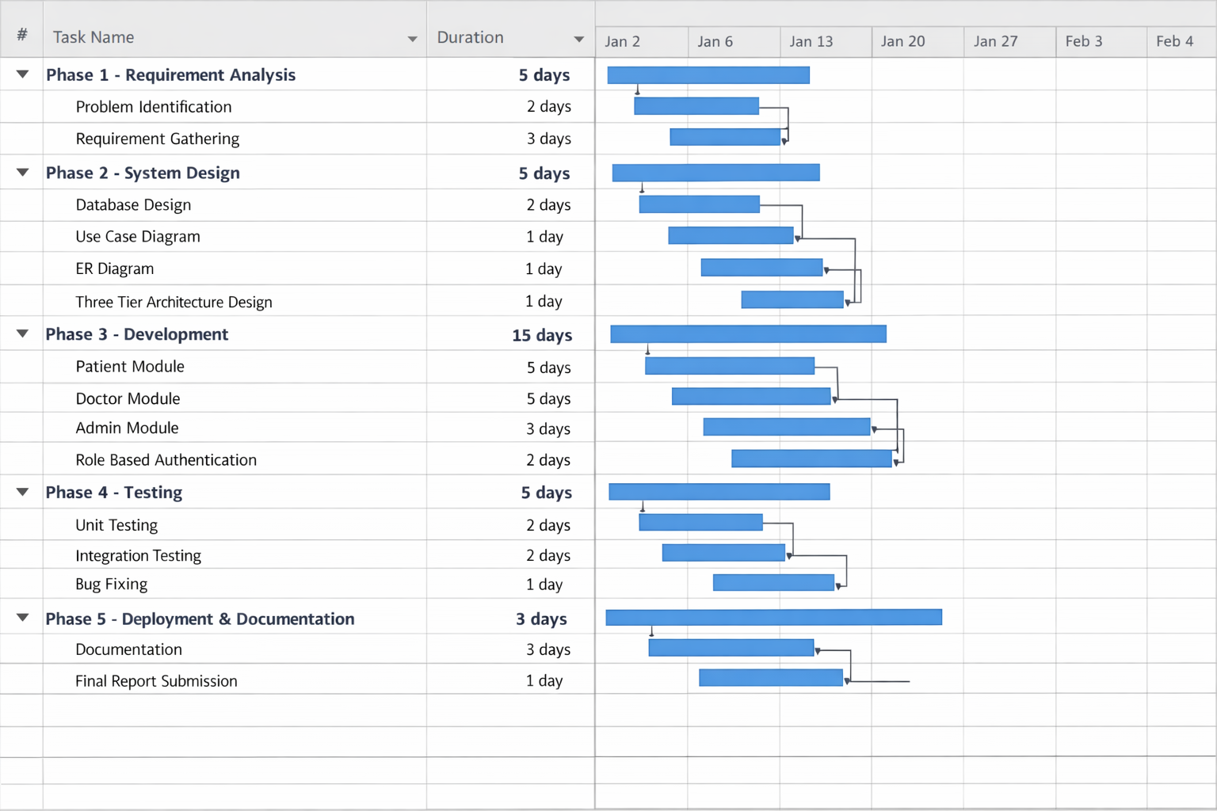

2. Literature Review
Hospital Management Systems have been widely implemented to improve healthcare efficiency. Studies show that automated systems reduce human error, improve data accessibility, and enhance patient satisfaction.
Existing systems highlight the importance of: - Role-based access control - Secure medical record management - Centralized appointment scheduling
This project follows best practices from existing HMS solutions while implementing a clean three-tier architecture for better maintainability and scalability.

3. System Architecture (Three-Tier Architecture)

Presentation Layer
- User Interface (Forms / Web Pages)
- Handles user interaction

Business Logic Layer (BLL)
- Application rules
- Role-based authorization
- Appointment and prescription logic

Data Access Layer (DAL)
- Database interaction
- CRUD operations
- SQL Server connectivity

4. Use Case Diagram
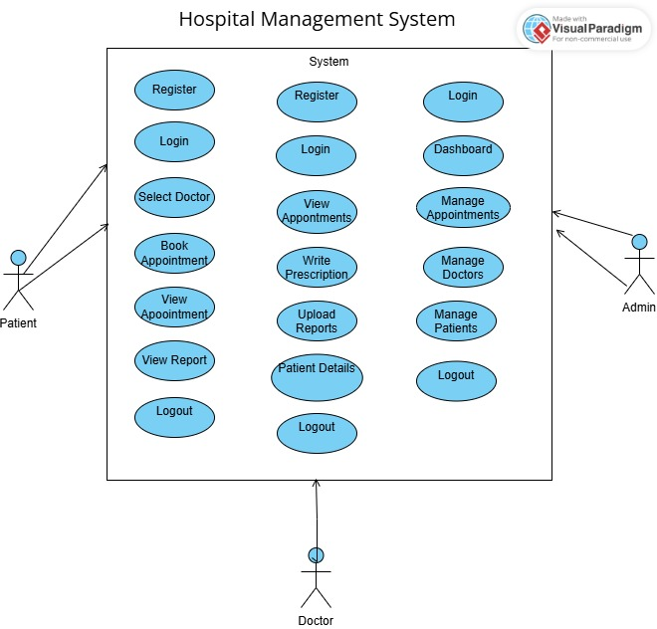

5. Conclusion
The Hospital Management System successfully automates hospital operations using a role-based three-tier architecture. The system improves efficiency, reduces manual workload, and ensures secure handling of medical data. It provides a scalable solution suitable for real-world hospital environments.

6. Future Enhancements
- Online payment integration
- SMS/Email appointment notifications
- Patient history analytics
- Mobile application support
- Advanced reporting and dashboards

7. Links
YouTube:
https://youtu.be/tYkQ_QYdNbo?si=epMbYk1HHmXO6aSW
GitHub:
https://github.com/hadii-4/Hospital-Management-System

